Dokumentation:

show ip nat translation (R1):

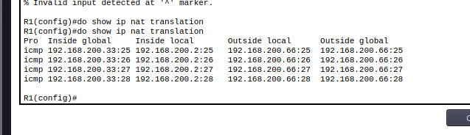
show ip nat translation (R2):

